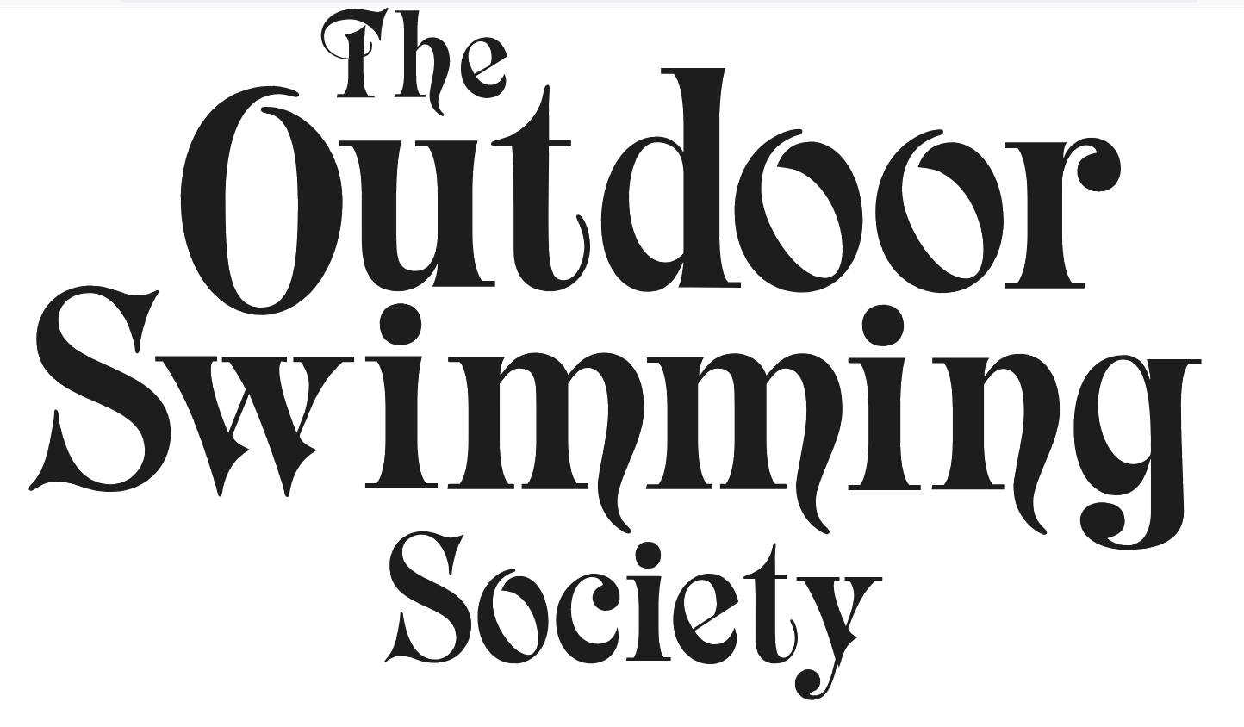
Outdoor Swimming Society (OSS) response to the consultation on whether
these should be designated as bathing waters in 2026:

10 locations inland (including estuaries):

• Little Shore, Amble, Northumberland
• Newton Noss, Devon
• Canvey Island Foreshore, Essex
• Queen Elizabeth Gardens Salisbury, Wiltshire
• Pangbourne Meadow, Berkshire
• River Fowey in Lostwithiel, Cornwall
• River Swale in Richmond, Yorkshire
• Falcon Meadow, Bungay, Suffolk
• River Thames at Ham and Kingston, Greater London
• River Dee, Sandy Lane, Chester, Cheshire

3 locations on the coast:

• Sandgate Granville Parade Beach, Kent
• East Beach at West Bay, Bridport, Dorset
• New Brighton Beach (East), Merseyside

The Outdoor Swimming Society, established in 2006, has grown from 300 members that year to around 200,000 by 2023, with massive growth in the last few years, now reaching well over 2 million people through its various channels. It brings together the swimming community and is a resource to that community. Part of the OSS mission is ‘Access for all’, and its Right to Swim (Inland) group provides support, resources and a network to those interested in improving swimming access for inland waters.

The view of OSS

OSS supports these proposals and believes that they should be designated as bathing waters. This would benefit swimmers and other water users, giving them information on bathing water quality so that they can make a decision on whether to enter the water and if so what precautions to take. In responding we are focusing particularly on the inland locations (river and estuary), where our concerns about access are most pressing.
We support all of the applications, though without further information we are not in a position to comment in detail on them.

Although bathing water designation has a narrow and specific purpose, the process should be seen in the wider context. A key priority for The Outdoor Swimming Society is to see access for all to go swimming – and improved access is especially needed inland.

The positive remarks from the Water Minister and the Mayor of London recognising the benefits of outdoor swimming and the value of bathing water sites, and the number of locations, together with the support from councils and other landowners, are a recognition that inland swimming is very popular and is a normal and enjoyable activity. This needs to be taken much further by recognising far more places and creating a much greater Right to Swim and access to water and land across the country.

Our reasons for supporting the proposals

It’s impressive to see how much work has been done by many swimmers and others in local communities to consult and count and put together their applications – clearly showing that swimmers care about their environment. Many campaigns have involved a lot of local people in citizen science water monitoring and in consultations. Most campaigns have fully involved swimmers and have worked with a variety of different local organisations and authorities, including conservation, river users, river catchment partnerships, landowners and water companies – and this is by far the best way to approach issues of bathing and ecological water quality. It’s particularly important to involve swimmers and to put them at the centre of such campaigns, so that all concerned fully understand the issues around outdoor swimming and come up with the most appropriate plan.

The impact of these designations will be that bathing water quality will be checked and publicised which should lead to improvements and give swimmers information. Swimming can be done safely with information. OSS provides information to swimmers on this and other issues in the Survive section of its website. On this subject it has these two relevant posts, Is it Clean, https://www.outdoorswimmingsociety.com/is-it-clean/, and 10 Ways To Stay Well Swimming, https://www.outdoorswimmingsociety.com/10-ways-to-stay-well-swimming/ and a related one about pollution and swimming after rain or when river levels are low, https://www.outdoorswimmingsociety.com/understanding-rain-windy-weather/.

The popularity of outdoor swimming and other water use has seen a dramatic rise in the last couple of years, and this has great benefit to local areas. Tourism and visitors are beneficial to local services, and these activities have great benefits to health and well-being of people, thus giving a wider benefit to society.

Swimmers and other water users who are immersing themselves and involved in the local water are there and they care, and these campaigns are increasing knowledge and involvement, meaning that more people are more likely to treasure and look after their local environment.

Improvements in bathing water quality and the measures that will make that come about are also beneficial to water quality for wildlife and the environment and biodiversity, which is clearly of benefit to all. Different aspects of water quality are clearly linked, though it is important to make a distinction between the two measures of water quality. (The suggested questions in the online consultation form could perpetuate confusion on this point: “I think it would help protect nature and wildlife; I think the water quality would be improved”)

Support for these proposals are clearly high in all the areas, and bathing places are clearly well used and popular with swimmers and other river users, so large numbers would benefit from designation and the information that would as a result be provided, and the longer term improvement which should hopefully follow from the organisations working together.

Facilities or infrastructure to promote bathing at the sites

OSS is not in a position to comment specifically on every location, particularly as the consultation document is lacking in detail.
Facilities are very useful for promoting access to places to swim outdoors inland, though not always essential, and some places are small and sensitive and inappropriate for such facilities but are perfectly appropriate for swimming by suitable numbers of people behaving responsibly.
Easy access, especially disabled access, is particularly important to ensure access for all. Those putting in applications should be more strongly encouraged to provide disabled access in consultation with groups representing disabled people in the area.
It is also important not to have negative signage that emphasises the ‘dangers’ of outdoor swimming, especially those that don’t then go on to explain how to stay safe. It isn’t essential to provide that information to people, other than unusual risks that people might not be aware of, but it can be helpful to provide a few key tips for those less familiar with outdoor swimming and to produce these in consultation with local swimmers or swim groups or to use resources such as those provided by the Outdoor Swimming Society on its website.

Other factors – physical safety, ecological sensitivity

We remain concerned about the recent consultation about changing parts of the procedure to designate, in particular the suggestion that physical safety, ecological sensitivity, and prohibitions on access be taken into account. It is not clear exactly what this means, but we are very concerned because as we said in the response to that consultation (December 2024), in the current climate outdoor swimming and safety related to it is very much misunderstood and therefore such factors could not be a fair and proper representation of the reality. This will lead to fewer places being put forward or accepted.

On one factor – physical safety – we are still in a state of limbo in which we have no idea whether we will be consulted and when, and what proposals might be put forward. Those wishing to consider applying for designation this year still have no idea whether these factors will be taken into account or not, which makes it very difficult for them to consult locally and consider whether to put all the work into such a campaign. We would much prefer this idea to be dropped, and meanwhile the lack of transparency and information is also extremely unhelpful.

We would also contend that the potential impact of swimming on the environment is also much misunderstood and exaggerated, and that might have a negative effect on places being put forward.

On this particular factor – ecological sensitivity – we note that there has been no consultation or transparency about exactly how account will be taken of environmental impacts, but it has been now included in the procedure.

The consultation document says that DEFRA has “consulted directly with Natural England to seek their views on any potential environmental impacts that should be considered”, but how would applicants have known that that was going to be done or had an opportunity to put forward their views and knowledge on this particular point? It is extremely poor practice to have brought in a criteria in this way without transparency, clarity or an opportunity to address potential issues in their applications.

In some of the applications there is reference to protected sites one or two or even 9 km away, and the connection is not clear. For example in relation to Falcon Meadow, it says that this is within “1.8km of Broome Heath Pit Site of Special Scientific Interest (SSSI).” However these two locations are not connected in any way. There is no water flow between the two, there is housing, a busy A road and some smaller roads between the two locations. So reference to it appears to be completely irrelevant and could be misconstrued.

We would like further clarity on how the consultation with Natural England was carried out, what information they were given, what their views were, what account was taken of that, and what weight given to it, in considering the application.

Clarity on purpose and meaning of bathing water designation

OSS has published information about the bathing water designation procedure, https://www.outdoorswimmingsociety.com/designated-bathing-waters-explained/, and information for local swimmers considering seeking a bathing water designation, including all the factors involved in the process, the benefits and potential negative consequences which can occur depending on how the campaigning takes place, https://www.outdoorswimmingsociety.com/should-swimmers-seek-bathing-water-designation-for-local-swim-spots/.

These proposals will have benefits and the campaigns are wide-ranging and inclusive of all who would be involved in improving quality and the information available to river users. However it is important to be aware of potential misunderstandings by members of the public and to make sure that information on the purpose and implications of designation is clearly communicated.

Designation of these places as bathing waters does not necessarily mean that other places that are not monitored are unsafe; swimmers will need to use information such as that in Is it Clean, https://www.outdoorswimmingsociety.com/is-it-clean/, and 10 Ways To Stay Well Swimming, https://www.outdoorswimmingsociety.com/10-ways-to-stay-well-swimming/ to make their own assessment.

Designation of these places as bathing waters does not mean that they have been assessed in relation to other risks, and the area cannot automatically be assumed to be clean and safe; swimmers and other users still need to assess risks and take appropriate precautions to make sure they are safe. That does not mean that it is necessarily dangerous; awareness of risks can ensure that people keep themselves safe. There can be specific risks in particular local water bodies, and any swimmers would be strongly recommended to join or liaise with local swim groups and others who are aware of the detailed nature of the locations.

Some of the applications are for tidal waters. OSS has a general article on staying safe in tidal rivers and estuaries, Understanding Tidal Rivers and Estuaries, https://www.outdoorswimmingsociety.com/understanding-tidal-rivers-and-estuaries/.

Designation does not impact upon the legal position on liability of landowners in relation to risks to swimmers. This position is much misunderstood, and that misunderstanding means that places where swimmers can get access are far too few for the high and increasing demand and desire to do so. The legal position is that swimmers choosing to enter the water would be aware of the normal risks of doing so, and landowners only need to warn of unusual risks that cannot be seen, and as long as they assess for such unusual risks they have done all they need to in relation to liability. This is clearly laid out in the guide published by The Outdoor Swimming Society, which includes advice for landowners & managers, and anyone who wants to see more swimming in lakes, rivers, and other inland waters. Read about and download the OSS Guide to Inland Bathing Areas, https://www.outdoorswimmingsociety.com/access-all-areas/

Although recognition of a place as a bathing water does not change the legal position or the risk of swimming, it can be an opportunity to provide information to river users, especially those less familiar with potential risks and benefits and on how best to be a responsible swimmer in relation to safety, other users and the environment, as outlined in the OSS Outdoor Swimmers Code, https://www.outdoorswimmingsociety.com/outdoor-swimmers-code/. This opportunity could be taken by all with an interest in making sure that everyone enjoys the river safely and responsibly and gains all the benefits.

Designation is not about promoting the sites and increasing numbers of visitors. Clearly these locations are already popular locations for swimmers and other users. It’s important to understand that outdoor swimming has a low impact on the environment and is done responsibly and with appreciation and care for nature and wildlife. And when people swim and gain a closer experience and understanding of their environment, surveys have clearly shown they are much more likely to respect it and to care for it, often actively as volunteers or advocates.

We welcome that the Water Minister Emma Hardy, in announcing the consultation said:
“Rivers and beaches are at the heart of so many communities – where people come together, families make memories and swimmers of all ages feel the benefits of being outdoors safely. Our plans to designate new bathing water sites show how we are backing local ambition and recognising the pride in places that matter most to people.”
https://www.gov.uk/government/news/communities-set-to-benefit-from-13-new-bathing-spots-proposed-across-england

The consultation process; disabled access

The consultation document is lacking in much detail for each location. The updated guidance included suggestions on the sorts of facilities on which information should be provided, and included this welcome point: “easy access (including disabled access)”. Improving access for all to swim would need improvements in disabled access. So it is disappointing that none of the application summaries mention this point. Applicants should be more strongly encouraged to provide disabled access in consultation with groups representing disabled people in the area.

The online consultation process is not very satisfactory. Unless you do the online consultation process it’s not possible to see what questions are being asked. It would be better to publish those questions alongside the document, otherwise responses made in a different way might not be counted and reported fully.

We would prefer account to be taken of the points we consider to be important and are making in this detailed response.
Please confirm that our response and those responses by email or by post that don’t necessarily only answer the specific and limited questions in the online form will be counted and fully considered in the report on the consultation.
We have chosen not to fill in the online form. Partly because of its narrowness, and partly because we would have to do it 13 times as there is no option to respond to more than one at a time, and that is an unreasonable expectation.

Question 9 – the potential misleading nature of points d) and f) has already been mentioned.
Questions 14 and 15 – It is meaningless to ask people about facilities and infrastructure at the site, particularly as all they have to go on is either local knowledge or what is in the very basic information in the consultation document. It is not necessarily clear what the questions mean, nor is the purpose of asking those questions. But if you are going to ask why not include the important issue of access for disabled swimmers.

It is welcome that this time a reasonable amount of time was allowed for consultation (and welcome this taking on board of criticism of the very short period allowed last time).

Much more information about each of the application should be published. The consultation document provides only the bare minimum which gives very little basis on which to judge and to understand the location and relevant issues.

General points about the current bathing water designation process

It has not been said whether applications have been put forward and rejected and if so on what basis. If it is because of lack of facilities or large enough number of bathers, then it is worth noting that the size of different swim locations vary considerably, as do facilities and infrastructure, and that it is not appropriate to expect large numbers at relatively small places – and our Outdoor Swimmers Code suggests that swimmers do what they can to mitigate overcrowding (https://www.outdoorswimmingsociety.com/outdoor-swimmers-code/). Having a set number has made it clearer, however that might result in places that should be suitable for designation not being included.

In appropriate locations more people would no doubt be swimming if it were not for the unfortunate general atmosphere in England which is antithetical to access to water to swim, including the widespread misunderstanding of legal liability, safety and other issues of responsibility for one’s own safety, and the general bias against people swimming in our rivers and other water bodies. We would want to see much better access in order to do this healthy, affordable, environmentally sensitive and enjoyable activity and to enable spreading information about doing so safety and responsibly.

We are working for much better access rights and understanding of swimmers and inland outdoor swimming so that all can enjoy and benefit from it. If this could be achieved then there would be far more people able to take part, with benefits to them, the community and wider society and the environment.

Ideally the bathing water designation process could play a positive part in achieving this, however the proposals to include physical safety, access and ecological sensitivity as factors, along with the lack of clarity on how this might be done, is likely to be unhelpful.

